

Department of Computer Science Faculty of Computing
UNIVERSITI TEKNOLOGI MALAYSIA

SUBJECT NAME: | DIGITAL LOGIC
SUBJECT CODE: | SECR1013
SEMESTER: | 1
LAB TITLE: | LAB 2: COMBINATIONAL DIGITAL CIRCUIT DESIGN SIMULATION USING DEEDS SIMULATOR
GROUP MEMBER : | - Name: Nur Athirah Syafiqah Binti Norhisyam  Email: nurathirahsyafiqah@graduate.utm.my  - Name: Azdayana Batrisyia Binti Azahari  Email: azdayanabatrisyia@graduate.utm.my  - Name: Irdina Hannah Binti Misnun  Email: irdinahannah@graduate.utm.my
SUBMITTED DATE: | 20/12/2024

COMMENTS:


MARKS:
Lab # 2

Combinational Digital Circuit Design Simulation Using Deeds Simulator

- Objective

  - To expose student with producing digital logic circuit, generating truth table and Timing Diagram with Deeds Simulator
  - To expose student with a complete cycle process of a combinatorial circuit design and simulate with Deeds Simulator

Material

Install Deeds Software for Windows

Introduction Deeds Simulator
The Digital Circuit Simulator d-DcS appears to the user as a graphical schematic editor, with a library of simplified logic components, specialized toward pedagogical needs and not describing specific commercial products.

As described before, the schematic editor allows building a simple digital networks composed of gates, flip-flops, pre-defined combinational and sequential circuits and custom-defined components (defined as Finite state machine).

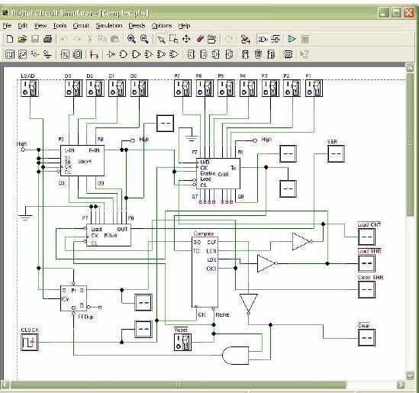

Fig. 1 Circuit Editor of Digital Circuit Simulator (d-DcS)

Simulation can be interactive or in timing-mode. In the first mode, the student can "animate" the digital system in the editor, controlling its inputs and observing the results. This is the simplest mode to examine a digital network, and this way of operation can be useful for the beginners. In the timing mode, the behavior of the circuit can be analyzed by a timing diagram window, in which the user can define graphically an input signal sequence and observe the simulation results.

Digital Circuit Simulator (d-DcS): A Simple Example

In following screen shots (Fig. 2a, 2b, and 2c), student can see the circuit during the drawing and then simulated by animation by following this simple steps:
- student picks-up components from the bin on the Component Tool Bar.
- connects them using Wires.
- student activates the animation.

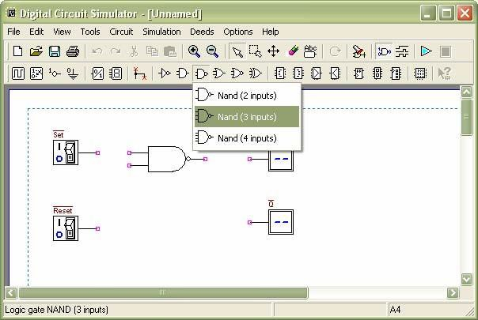

Fig. 2a Drawing Phase of the Digital Circuit Editor: Insertion of Components
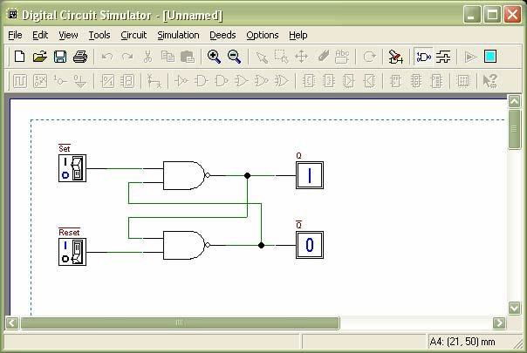

Fig. 2b Next Phase of the Work: Connection of Components using Wires

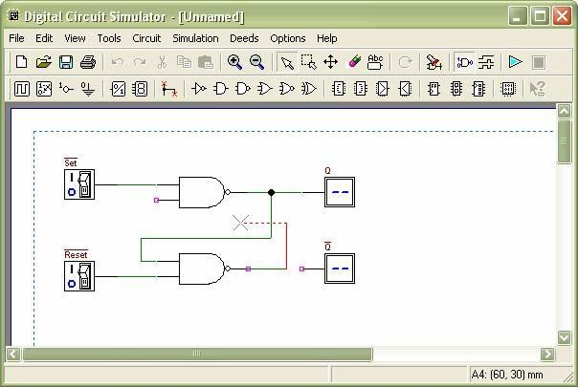

Fig. 2c Animation: User Switches Inputs and the Circuit Shows Changes on Outputs To exit the ‘animation’ mode, it is necessary to click on the square ‘stop’ button.
Instead, if the timing simulation is to be performed, student should click on the Timing Simulation button. This will show the Timing Diagram simulation window (Fig. 3).
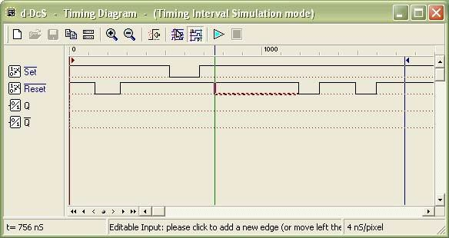

Fig. 3 Timing Diagram Simulation Window

In this window, first student should define the timing of the input signals, drawing them on the
diagram with the mouse. A vertical line cursor permits to define the ‘end time’ of the simulation. When student clicks on the triangular ‘play’ button on the toolbar, the simulation is executed, and its results are displayed in the same window (Fig. 4).
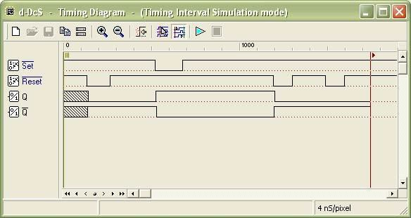
Fig. 4 Timing Simulation Results, Displayed in Timing Diagram Window

Student can verify the correct behavior of the network under test, comparing simulation results with reasoning and theory concepts.

Experiment

  - Part A:
Refer to circuit in Figure 1.
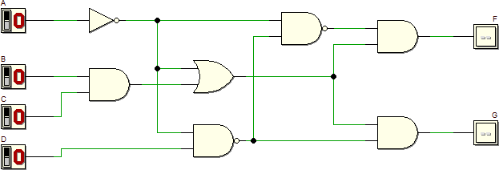

- Refer to the circuit. Derive Boolean expression for output F and G.

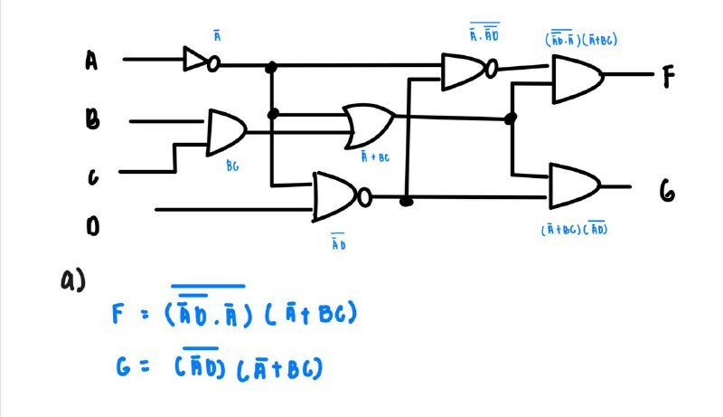

- Simplify equation output F using laws, rules and De Morgan Theorem, and write the equation in Sum of Product (SOP).

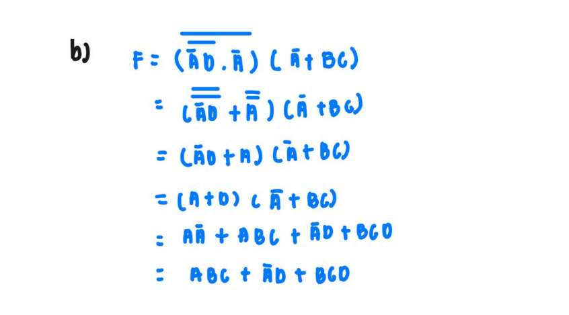

- Simplify equation output G using laws, rules and De Morgan Theorem, and write the equation in Product of Sum (POS).

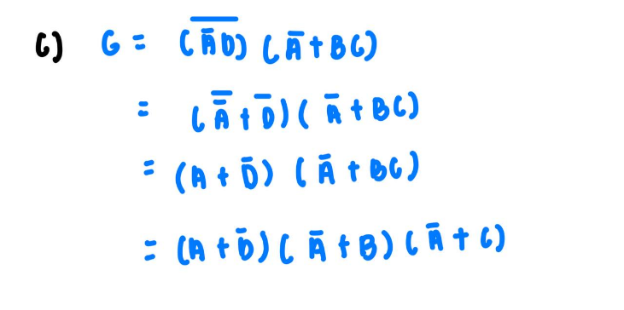
- Simulate the circuit and construct the truth table and complete the following.

Truth table for output circuit F and G shown in Figure 1

Input |  |  |  | Output
A | B | C | D | F | G
0 | 0 | 0 | 0 | 0 | 1
0 | 0 | 0 | 1 | 1 | 0
0 | 0 | 1 | 0 | 0 | 1
0 | 0 | 1 | 1 | 1 | 0
0 | 1 | 0 | 0 | 0 | 1
0 | 1 | 0 | 1 | 1 | 0
0 | 1 | 1 | 0 | 0 | 1
0 | 1 | 1 | 1 | 1 | 0
1 | 0 | 0 | 0 | 0 | 0
1 | 0 | 0 | 1 | 0 | 0
1 | 0 | 1 | 0 | 0 | 0
1 | 0 | 1 | 1 | 0 | 0
1 | 1 | 0 | 0 | 0 | 0
1 | 1 | 0 | 1 | 0 | 0
1 | 1 | 1 | 0 | 1 | 1
1 | 1 | 1 | 1 | 1 | 1

- Using Deeds, draw circuit in Figure 1. Simulate and complete the waveform output F and G by referring the following diagram:

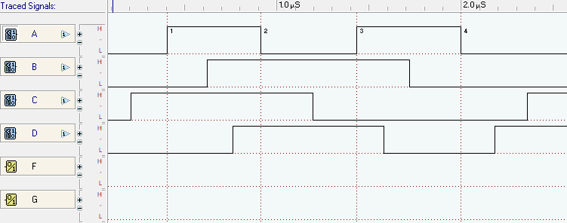

Answer

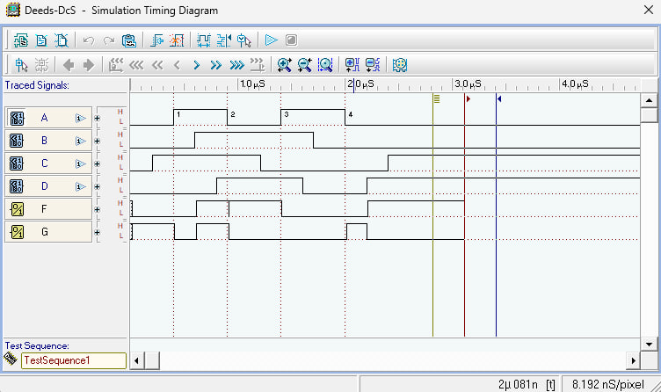

- Write Boolean equation for output F using Sigma notation.
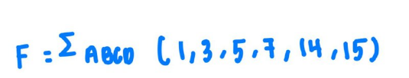

- Write Boolean equation for output G using Pi notation.



Part B:
Combinational circuit design process and simulate with Deeds Simulator

Design Process
- Determine Parameter Input / Output and their relations
- Construct Truth Table
- Using K-Map, get the SOP optimized form of all Boolean equation outputs
- Draw the circuit and use duality symbol; convert AND-OR circuit to NAND gates ONLY.
- Simulate the design using Deeds Simulator. Check the results according to Truth Table and Timing Diagram Operation.

Problem Situation
Using universal gate NAND gates only, design a logic circuit that controls an LRT coach door OPEN
operation at 3 LRT Stations: Pandan (S1), Pudu (S2) and Maluri (S3). Consider the following inputs:
- LRT coach moving status (S)
  - S = bit 1 indicates the coach has stopped.
  - S = bit 0 indicates the coach is moving.
- Sensor location at Station S1, S2, and S3
  - HIGH indicates the LRT coach has arrived at the particular station. For instance, S1 = 1 indicates LRT coach has arrived at station S1, and sensor S2=S3=0.
  - It is IMPOSSIBLE for the LRT coach to arrive at more than one station at one time.

The circuit outputs are the OPEN and ALARM signal
- OPEN = bit 1 indicates the coach door will be opened
- ALARM =bit 1 indicates the alarm is activated

The following are the conditions for OPEN and ALARM outputs at Station S1, S2, and S3
- The door will be opened ONLY IF the coach stopped at any ONE of the stations.
- The alarm will be activated:
  - If the coach arrives at any station and it does not stop. or
  - If the coach stopped but NOT at stations S1, S2 or S3.

Experimental steps
- Construct Truth Table in Table 1 for the LRT operations. Use variables S, S1, S2, and S3 as INPUTS and OPEN and ALARM as OUTPUTS.
Table 1

INPUT |  |  |  | OUTPUT
S | S1 | S2 | S3 | OPEN | ALARM
0 | 0 | 0 | 0 | 0 | 0
0 | 0 | 0 | 1 | 0 | 1
0 | 0 | 1 | 0 | 0 | 1
0 | 0 | 1 | 1 | x | x
0 | 1 | 0 | 0 | 0 | 1
0 | 1 | 0 | 1 | x | x
0 | 1 | 1 | 0 | x | x
0 | 1 | 1 | 1 | x | x
1 | 0 | 0 | 0 | 0 | 1
1 | 0 | 0 | 1 | 1 | 0
1 | 0 | 1 | 0 | 1 | 0
1 | 0 | 1 | 1 | x | X
1 | 1 | 0 | 0 | 1 | 0
1 | 1 | 0 | 1 | x | x
1 | 1 | 1 | 0 | x | x
1 | 1 | 1 | 1 | x | x

- Use K-Map to get optimized SOP Boolean equations for the OPEN and ALARM circuits.

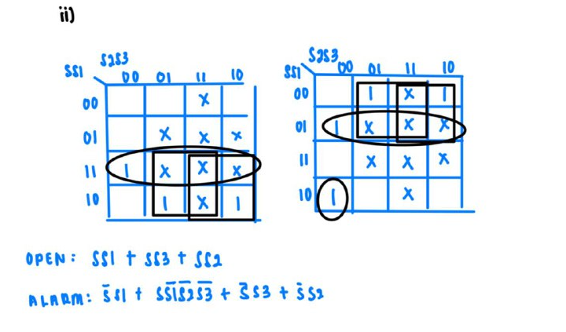

- From equations in (ii), draw your final OPEN and ALARM circuits using Deeds Simulator.

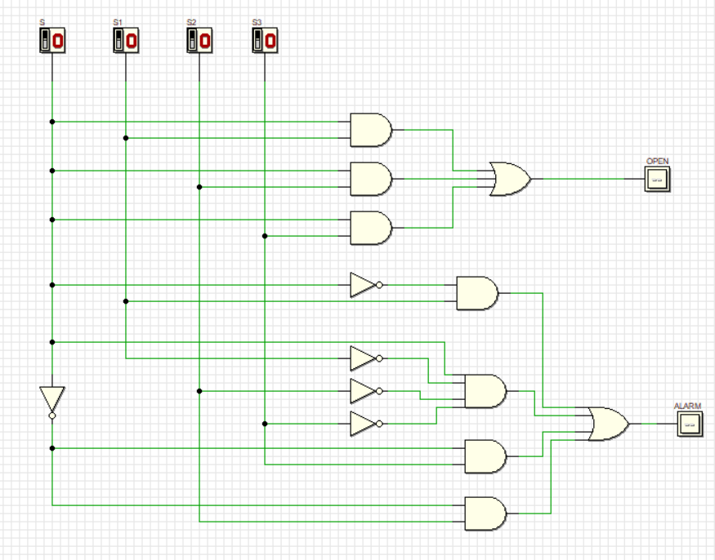
- Simulate the circuit design in (iii) and construct Truth Table in Table 2.

Table 2

INPUT |  |  |  | OUTPUT
S | S1 | S2 | S3 | OPEN | ALARM
0 | 0 | 0 | 0 | 0 | 0
0 | 0 | 0 | 1 | 0 | 1
0 | 0 | 1 | 0 | 0 | 1
0 | 0 | 1 | 1 | 0 | 1
0 | 1 | 0 | 0 | 0 | 1
0 | 1 | 0 | 1 | 0 | 1
0 | 1 | 1 | 0 | 0 | 1
0 | 1 | 1 | 1 | 0 | 1
1 | 0 | 0 | 0 | 0 | 1
1 | 0 | 0 | 1 | 1 | 0
1 | 0 | 1 | 0 | 1 | 0
1 | 0 | 1 | 1 | 1 | 0
1 | 1 | 0 | 0 | 1 | 0
1 | 1 | 0 | 1 | 1 | 0
1 | 1 | 1 | 0 | 1 | 0
1 | 1 | 1 | 1 | 1 | 0

Compare the answer of Table 2 and Table 1. What is your conclusion?

Table 1 does not have complete output while Table 2 provides a complete and resolved version of Table

1 by filling in the x values with specific outputs (0 or 1). The system's behavior matches expectations when

active (S = 1), and the alarm functions correctly when the system is inactive (S = 0) based on sensor

triggers.

- Use dual symbol to convert, AND-OR circuit to NAND gates only. Draw the final circuit using Deeds Simulator.

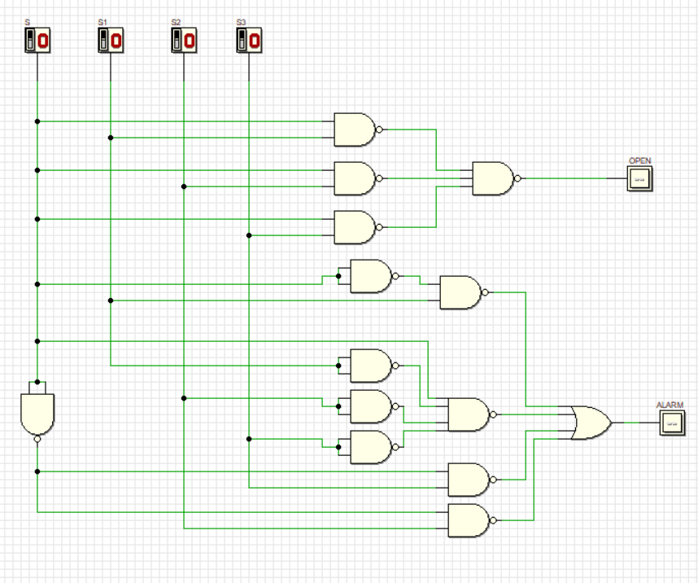
`

- Simulate the final NAND gates design in (v) and construct Truth Table in Table 3.

Table 3

INPUT |  |  |  | OUTPUT
S | S1 | S2 | S3 | OPEN | ALARM
0 | 0 | 0 | 0 | 0 | 0
0 | 0 | 0 | 1 | 0 | 1
0 | 0 | 1 | 0 | 0 | 1
0 | 0 | 1 | 1 | 0 | 1
0 | 1 | 0 | 0 | 0 | 1
0 | 1 | 0 | 1 | 0 | 1
0 | 1 | 1 | 0 | 0 | 1
0 | 1 | 1 | 1 | 0 | 1
1 | 0 | 0 | 0 | 0 | 1
1 | 0 | 0 | 1 | 1 | 0
1 | 0 | 1 | 0 | 1 | 0
1 | 0 | 1 | 1 | 1 | 0
1 | 1 | 0 | 0 | 1 | 0
1 | 1 | 0 | 1 | 1 | 0
1 | 1 | 1 | 0 | 1 | 0
1 | 1 | 1 | 1 | 1 | 0

Compare the answer of Table 2 and Table 3. What is your conclusion?

Table 2 and Table 3 have the same output because NAND-only gates circuit can replicate the

behavior of an AND-OR circuit as NAND gate is a universal gate. Both implement the same

Boolean expression. The difference lies only in the hardware implementation, not in the logic they

perform.

Fully Completed |  | Partially Completed |  | Checked by:

